**1.INTRODUCTION**

1.1 Project Overview

Medical inventory management is the process of overseeing medical and pharmaceutical supplies, from procurement to disposal, to ensure healthcare professionals have the right items at the right time. It involves tracking inventory levels, managing expiration dates, controlling costs, and maintaining compliance with regulations. The goals are to prevent stockouts and waste, improve patient safety by ensuring access to necessary supplies, optimize resource allocation, and enhance overall operational efficiency in healthcare facilities.



**1.2 Purpose**

The purpose of medical inventory management is to ensure optimal stock levels of medical supplies and pharmaceuticals, which is crucial for patient safety, operational efficiency, and cost control within healthcare facilities. It achieves this by enabling healthcare providers to have the right items, in the right quantities, at the right time, minimizing waste from overstocking and preventing critical shortages that could disrupt patient care.

**DEVELOPMENT PHASE :**

Creating Developer Account: By using this URL - [**https://www.salesforce.com/form/developer-signup/?d=pb**](https://www.salesforce.com/form/developer-signup/?d=pb)

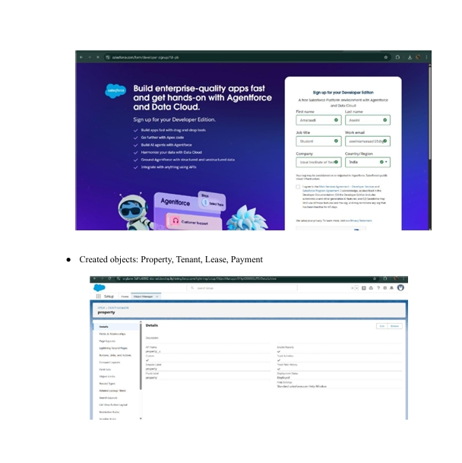

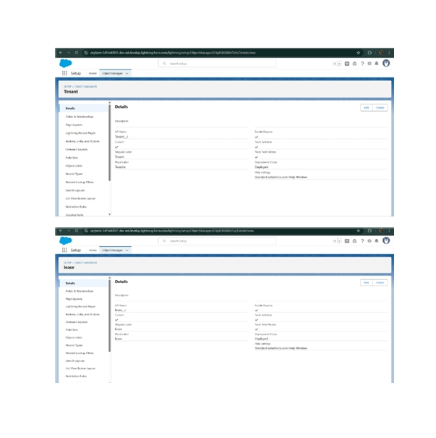

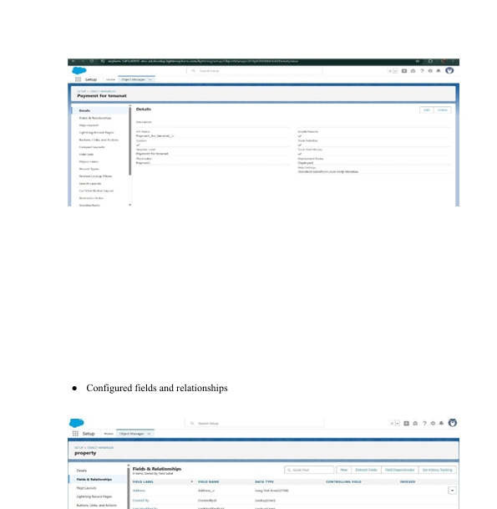

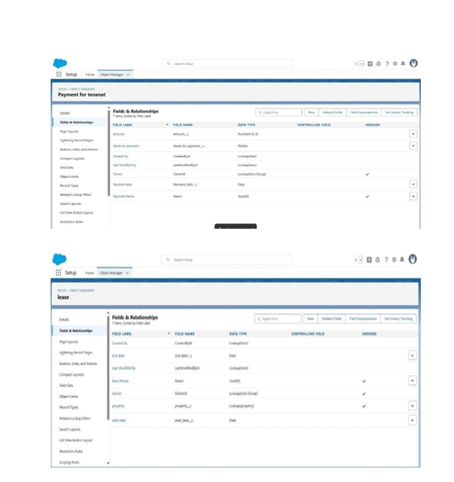

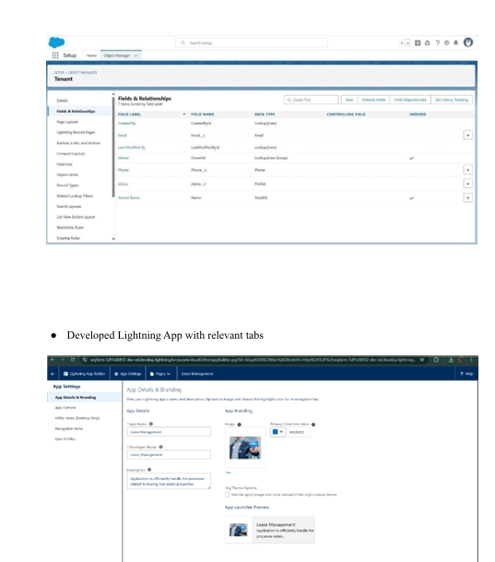

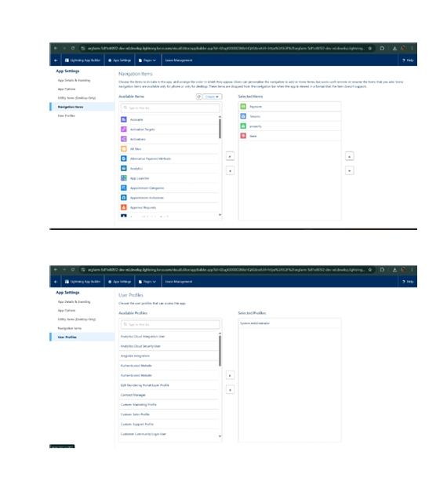

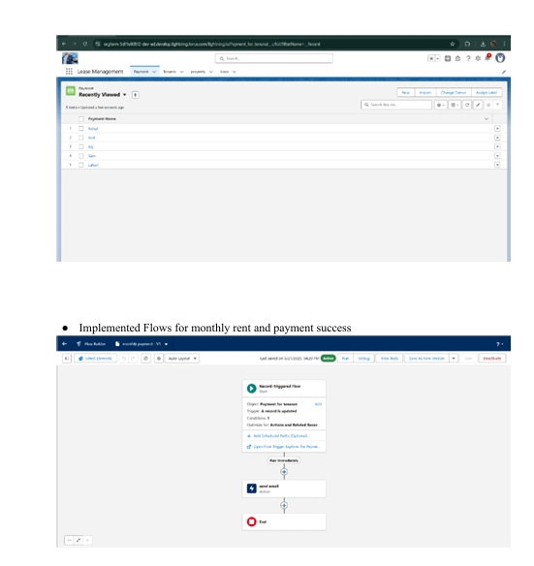

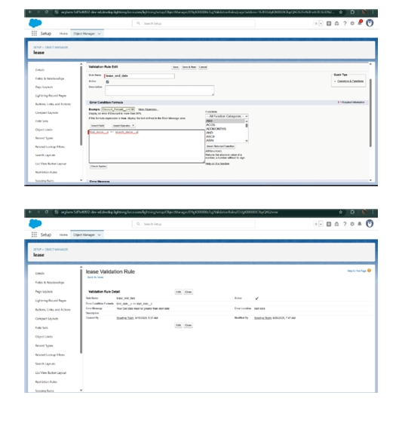

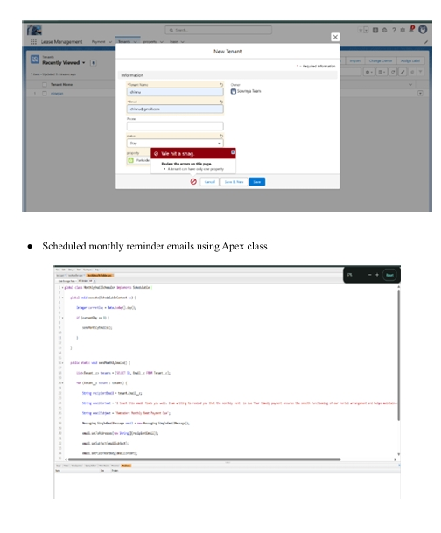

**CONCLUSION:**

Effective medical inventory management is crucial for cost reduction, operational efficiency, and enhanced patient care in healthcare facilities. By leveraging strategies like demand forecasting, just-in-time inventory, and automated software, hospitals can ensure a continuous supply of essential items, minimize waste from expired or unused stock, and maintain regulatory compliance. This leads to better inventory control, reduced financial burdens, and improved overall quality of care delivery.